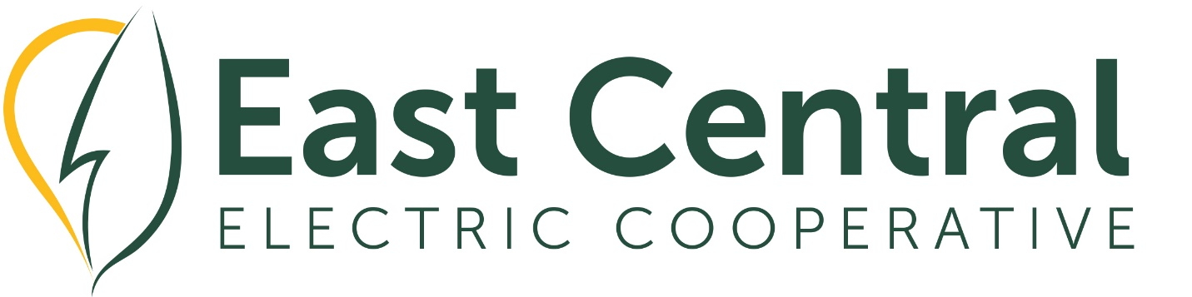

Dear Educator,
Do you know an outstanding high school student who would be a great candidate for Oklahoma Youth Expo/Leadership Summit?
East Central Electric Cooperative will be sponsoring two students to attend Leadership Summit.
Students will spend the day performing different leadership activities and work with other students for group leadership projects.
Students will get to hear from nationally renowned speakers that will discuss the importance of being a leader in our communities and teach them about self-reflection and self-development.
Each student will receive a $500 scholarship, certificate, shirt, and branded items during the event.
Please complete the Leadership Summit Nomination Form and attach a letter of recommendation to the form.
Nomination deadline is February 1, 2023.
Nomination and Reference letter must be returned to East Central Electric on or before February 1, 2023.
Return to: Penny Kendrick, Youth Programs Coordinator, pkendrick@ecoec.com or mail to the attention of Penny Kendrick at East Central Electric Cooperative, P O Box 1178, Okmulgee OK 74447.

2023 Leadership Summit Nomination Form
NOTE: This is not an official entry or guaranteed selection for the 2023 Leadership Summit.

Contact Name *
______________________________ ______________________________
First Name Last Name
Contact Email *
_____________________________________________________________________
example@example.com
Nominee Name *
__________________________ ____________________________________
First Name Last Name

Nominee Email *
______________________________________________________________________example@example.com

Nominee Phone*
______________________________________________________________________(000) 000-0000

Nominee High School *
______________________________________________________________________
Nominee Current Grade * ________________

Nominee Parent/Guardian Name*
___________________________ _____________________________________
First Name Last Name

Nominee Parent/Guardian Email *
______________________________________________________________________example@example.com

Nominee Parent/Guardian Phone*

__________________________________
(000)000-0000

2023 OYE/Leadership Summit – March 13, 2023
Leadership Summit will be held at the Oklahoma State Fairgrounds,
Barn 3 Pavilion 3001 General Pershing Blvd. Oklahoma City, OK 73107

What will I gain from Leadership Summit?
$500 scholarship + certificate
You will get to hear from two amazing speakers.
Rhett Laubach and Kelly Barnes are Oklahoma natives and have collectively spent over 40 years sharing leadership messages with students and adults in the education, agriculture, insurance, health, transportation, and sales industries. Their presentation style is very interactive and engaging and the content they will share is both tangible and relevant to the student leaders who will be attending the conference.
The content Rhett and Kelly will share is focused on how to make the most of the service and growth opportunities in front of you today and in the future. The attendees will increase their understanding of how leaders create change, overcome obstacles, and serve others through their behavior and attitude.
You can learn more information about Rhett at www.YourNextSpeaker.com.
You can learn more about Kelly at www.KellyBarnes.com.

Student Attire: Be sure to wear comfortable, school-appropriate clothing you can move around in … a shirt to represent your school would be great!

Transportation:
If selected, please contact Penny Kendrick. pkendrick@ecoec.com Youth Programs Coordinator to coordinate how you will be traveling to and from Leadership Summit.

